2023 New Zealand Seniors & Veterans Chess Championships
new zealand seniors and veterans chess championships (ross spiller memorial) 24th to 27th August 2022 | Organised by chessventures in association with the invercargill-southland chess club
ascot park hotel  Cnr Tay Street & Racecourse Road  Invercargill | Organiser: Richard Christie / chessventures  Ph: (021) 111 5662  Chief Arbiter: NA Richard Christie  Ph: (021) 111 5662
Website: www.riccartonpark.nz

Prizes

Seniors
($500 Minimum guaranteed Prize Fund, final prize fund dependent on entries received)
First | $250
Second | $150
Third | $100

Veterans
($100 Minimum guaranteed Prize Fund, final prize fund dependent on entries received)
First | $100

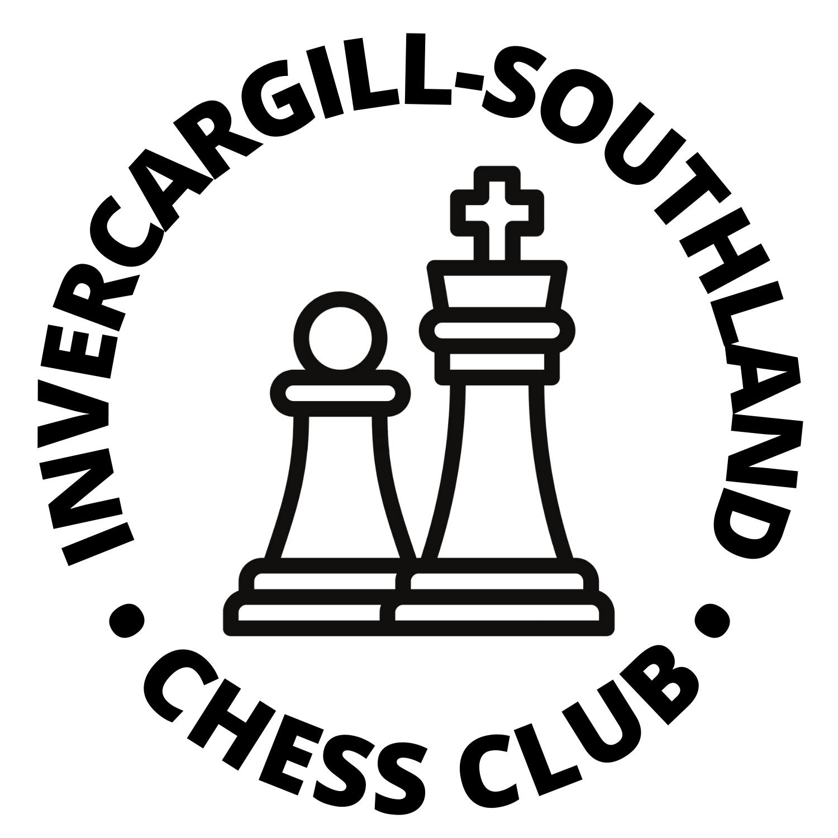

24-24 August 2022
Format: 6 Round Swiss tournament
Time Control: 90 minutes with an additional 30 seconds per move from move one (90 + 30).
Entry Fees: On or before 27 July 2022 $60 (Early Bird Discount!). 28 July and later $80
Registration: Players must register between 1:00pm and 2:00pm on Thursday 24 August 2023 either in person or by text message or email to the organiser/chief arbiter or risk not being paired in the first round.
Players Meeting: 2:00pm on Thursday 24 August 2023
Playing Schedule:
Thursday 24 August | 1:00pm | Registration (Check in) Opens
Thursday 24 August | 2:00pm | Registration (Check in) Closes
Thursday 24 August | 2:00pm | Players’ Meeting
Thursday 24 August | 2:30pm | Round 1
Friday 25 August | 9:30am | Round 2
Friday 25 August | 2:30pm | Round 3
Saturday 26 August | 9:30am | Round 4
Saturday 26 August | 2:30pm | Round 5
Sunday 27 August | 9:30am | Round 6
Sunday 27 August | After Round 6 | Prizegiving

Ratings: The tournament will be NZCF-rated and FIDE-rated. For the purposes of pairings and grade prizes, NZCF standard ratings will be used. Where players do not have a published NZCF rating, the Chief Arbiter may assign a rating at his discretion. Please note that all NZ players must be registered with NZCF – unregistered players may register when entering or at the event for $20 (through the Invercargill-Southland Chess Club). Non-NZ players must have a FIDE ID prior to entering.
Half-point byes: To give flexibility to chess enthusiasts combining the tournament with a holiday, players may request up to two half point byes but not in the last 3 rounds. The Chief Arbiter must be informed before the end of the previous round or when entering for first round byes.
Prizegiving: At the venue as soon after Round 6 has been completed - approximately 2:00pm.
Prize Fund: Minimum guaranteed prize fund of $600 across both categories (see breakdown on left).
new zealand seniors and veterans chess championships 24th to 27th August 2023

Eligibility: Players must be over the age of 49 on 1st January 2023 (born before the year 1974).
Titles: The highest-placed New Zealand player shall the be the New Zealand Seniors Chess Champion.
The highest-placed player over the age of 64 on 1st January 2023 (born before the year 1959) shall be the New Zealand Veterans Chess Champion.
Titles will be shared if there is a tie.
Note: No player may claim more than one prize. In the event of a tie, prize money will be shared. Winners will have their names engraved on the official NZCF trophies and NZ Master points will also be available.

Tournament Regulations
new zealand seniors and veterans chess championships 24th to 27th August 2023
Event Sponsor
The Invercargill-Southland Chess Club & chessventures gratefully acknowledge our major sponsor:
TBC

NZCF and FIDE Rating: The tournament will be NZCF-rated and FIDE-rated if possible.
Pairings and Rating-Based Prizes: NZCF ratings will be used for pairings and rating-based prizes. ratings. Players without ratings may be assigned a rating by the Chief Arbiter. The most recently-published rating lists will be used (June for NZCF, August for FIDE).
Defaults: Per NZCF Regulations, default time is 30 minutes after the start of the round.
Appeals: A player may appeal against a decision of the Arbiter in a tournament. An Appeals Committees will be appointed by the Organiser from the players. Appeals must be lodged in writing within 30 minutes of the end of the game. A fee of $50 will apply, to be refunded if the appeal is successful or otherwise at the discretion of the Appeals Committee.
Mobile Phones / Electronic Devices: During a game, players are forbidden to have a mobile phone, electronic means of communication or any device capable of suggesting chess moves on their person in the playing venue. Such devices may be stored in a player's bag or jacket, which is to be left under their table or the back of their chair during the game unless permission is given by the Arbiter. Such devices are to be switched off and are not to make any noise. Breaches of this rule will result in loss of game unless the Arbiter decides otherwise. This includes smart watches but not standard analogue or digital watches.
Photos: Spectators may take photos during the first 5 minutes of a round.
Covid-19: The 2023 New Zealand Seniors Chess will be played subject to any relevant Covid-19 legislation and or/guidelines which are in place at the time. These will be published once it is clear which, if any, legislation and or/guidelines will be in place during the tournament dates.
Refunds: If a player withdraws prior to or on 24 August 2023, their entry fee will be refunded. If a player is removed from a tournament or otherwise unable to play or continue on or after 24 August 2023, no refund will be paid. NZCF, Invercargill-Southland Chess Club, chessventures or any organiser or arbiter will not be liable for any consequential loss if the tournament is cancelled or a player withdraws or is subject to any action or penalty under NZ Law, the Laws of Chess, NZCF or FIDE Rules or Regulations, or these tournament regulations.
Accommodation: Possible accommodation deals TBC

Entry Form
new zealand seniors and veterans chess championships 24th to 27th August 2023

Name |  | Phone No.
Email |  | Date of Birth
NZCF ID |  | FIDE ID
NZCF Rating |  | FIDE Rating

NZCF ID and ratings are available at http://newzealandchess.co.nz/ratings.html and FIDE ID and ratings at https://ratings.fide.com/. NZ citizens and residents without FIDE ID numbers will have them issued by NZCF (please provide date of birth). Foreign players must provide a FIDE ID number.
NZ players who play in 2 or more NZCF-rated tournaments in a calendar year must be a member of a chess club which is an NZCF affiliate or associate member.
If paying by internet banking, please complete the entry form above and email it to invercargillchess@gmail.com. Payment should be made via internet banking to 03-1369-0379529-00 – please include your surname and ‘NZ Seniors’ as references.
Entries are not confirmed until payment is received.
Confirmed entries will be listed online at www.newzealandchess.co.nz in the Calendar section.

