2023 Southern Chess Classic
southern chess classic (incorporating the all southland championships) | Organised by chessventures in association with the invercargill-southland chess club
invercargill bridge club  50 Elles Road  Invercargill | Organiser: Richard Christie / chessventures  Chief Arbiter: NA Richard Christie  Ph: (021) 111 5662  Ph: (021) 111 5662
Website: www.riccartonpark.nz

Prizes

($500 Minimum guaranteed Prize Fund, final prize fund dependent on entries received)
First | $200
Second | $120
Third | $80
Southland | $50
U1700 | $50

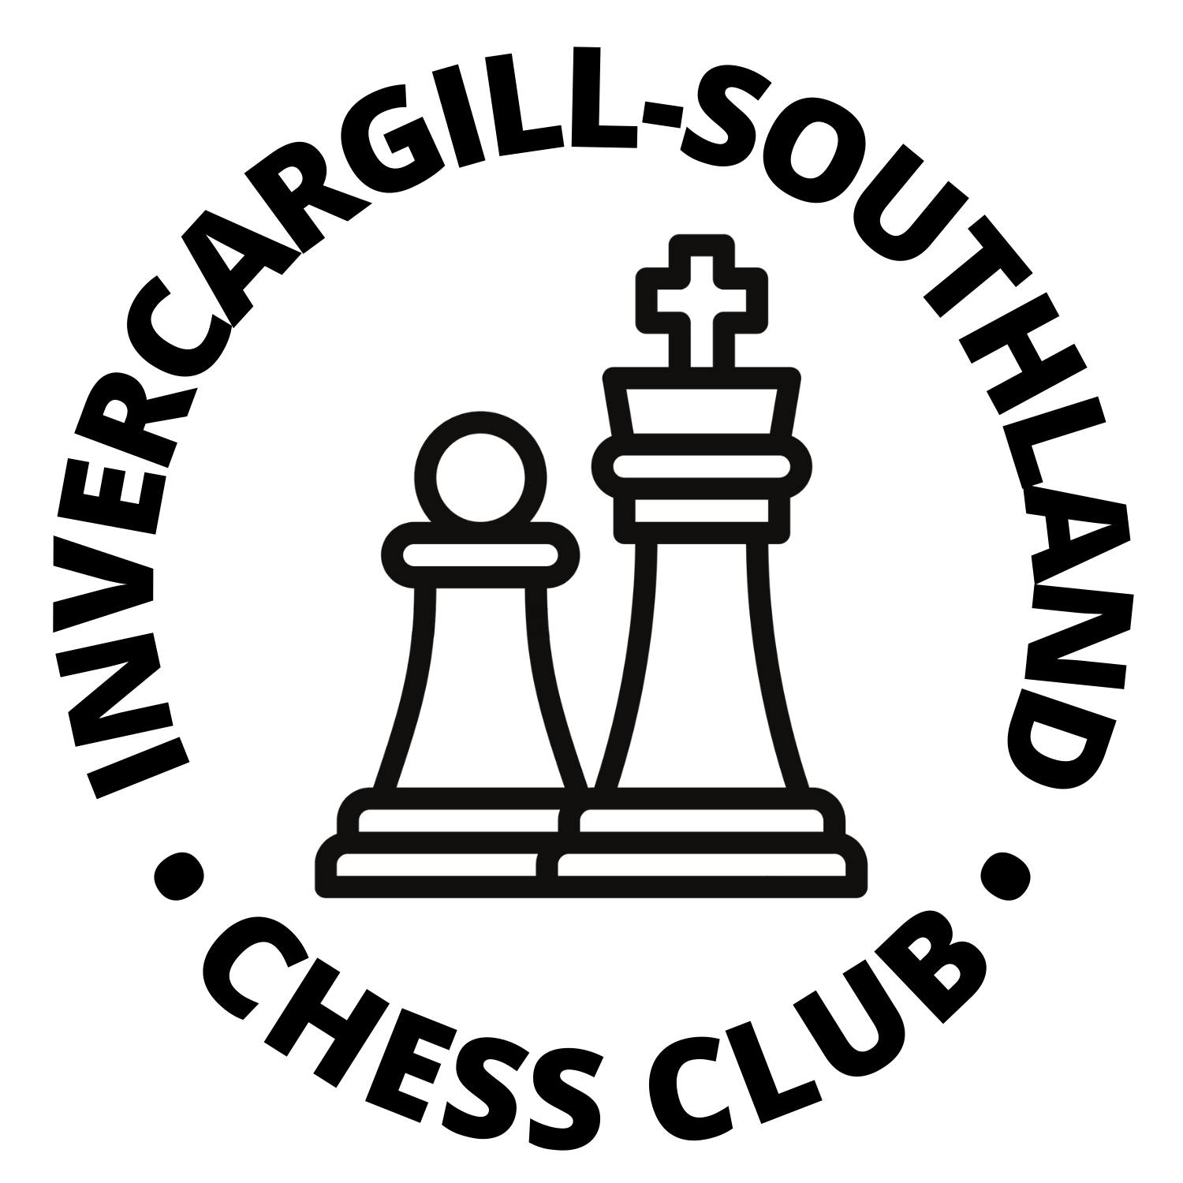

14-16 July 2023
Format: 6 Round Swiss tournament
Time Control: 60 minutes with an additional 30 seconds per move from move one (60 + 30).
Entry Fees: On or before 30 June 2023 (Early Bird Discount!)
Adult $50
Juniors/U20 $30
After 30 June 2023
Adult $60
Juniors (born on or after 1 Janaury 2003) $40
Registration/Check-in: Players must register/check-in between 5pm and 6:15pm on Friday 14 July 2023 either in person or by text message or email to the organiser/chief arbiter or risk not being paired in the first round.
Players Meeting: 6:30pm on Friday 14 July 2023
Playing Schedule:
Round 1 Friday 14th 7:00pm
Round 2 Saturday 15th 9:00am
Round 3 Saturday 15th 2:00pm
Round 4 Saturday 15th 7:00pm
Round 5 Sunday 16th 9:00am
Round 6 Sunday 16th 2:00pm
Ratings: The tournament will be NZCF-rated and FIDE-rated. For the purposes of pairings and grade prizes, NZCF standard ratings will be used. Where players do not have a published NZCF rating, the Chief Arbiter may assign a rating at his discretion. Please note that all NZ players must be registered with NZCF – unregistered players may register when entering or at the event for $20 (through the Invercargill-Southland Chess Club). Non-NZ players must have a FIDE ID prior to entering.
Half-point byes: To give flexibility to chess enthusiasts combining the tournament with a holiday, any player may elect to take one half-point bye, to be taken no later than round four. The Chief Arbiter must be informed before the end of the previous round or when entering for first round byes.
Prizegiving: At the venue as soon after Round 6 has been completed - approximately 5:30pm.
Prize Fund: Minimum guaranteed prize fund of $500 (see breakdown on left).
The highest-placed Southland resident will be the All Southland Chess Champion. Prizes will be shared between players on the same number of points - tie-breaks will not be used. Players may not win more than one open or grade prize, but may win the All Southland Chess Championship prize as an additional prize.

Tournament Regulations
2023 southern chess classic (incorporating the all southland chess championships)
Event Sponsor
The Invercargill-Southland Chess Club & chessventures gratefully acknowledge our major sponsor:
TBC

NZCF and FIDE Rating: The tournament will be NZCF-rated and FIDE-rated if possible.
Pairings and Rating-Based Prizes: NZCF ratings will be used for pairings and rating-based prizes. ratings. Players without ratings may be assigned a rating by the Chief Arbiter. The most recently-published rating lists will be used (June for NZCF, July for FIDE).
Defaults: Per NZCF Regulations, default time is 30 minutes after the start of the round.
Appeals: A player may appeal against a decision of the Arbiter in a tournament. An Appeals Committees will be appointed by the Organiser from the players. Appeals must be lodged in writing within 30 minutes of the end of the game. A fee of $50 will apply, to be refunded if the appeal is successful or otherwise at the discretion of the Appeals Committee.
Mobile Phones / Electronic Devices: During a game, players are forbidden to have a mobile phone, electronic means of communication or any device capable of suggesting chess moves on their person in the playing venue. Such devices may be stored in a player's bag or jacket, which is to be left under their table or the back of their chair during the game unless permission is given by the Arbiter. Such devices are to be switched off and are not to make any noise. Breaches of this rule will result in loss of game unless the Arbiter decides otherwise. This includes smart watches but not standard analogue or digital watches.
Photos: Spectators may take photos during the first 5 minutes of a round.
Covid-19: The 2023 Southern Chess Classic will be played subject to any relevant Covid-19 legislation and or/guidelines which are in place at the time. These will be published once it is clear which, if any, legislation and or/guidelines will be in place during the tournament dates.
Refunds: If a player withdraws prior to or on 13 July 2023, their entry fee will be refunded. If a player is removed from the tournament or otherwise unable to play or continue on or after 14 July 2023, no refund will be paid. NZCF, Invercargill-Southland Chess Club, chessventures or any organiser or arbiter will not be liable for any consequential loss if the tournament is cancelled or a player withdraws or is subject to any action or penalty under NZ Law, the Laws of Chess, NZCF or FIDE Rules or Regulations, or these tournament regulations.
Refreshments: Free Coffee & Tea will be provided at the venue
Accommodation: Possible accommodation deals to be confirmed

Entry Form
2023 southern chess classic (incorporating the all southland chess championships)

Name |  | Phone No.
Email |  | Date of Birth
NZCF ID |  | FIDE ID
NZCF Rating |  | FIDE Rating

NZCF ID and ratings are available at http://newzealandchess.co.nz/ratings.html and FIDE ID and ratings at https://ratings.fide.com/. NZ citizens and residents without FIDE ID numbers will have them issued by NZCF (please provide date of birth). Foreign players must provide a FIDE ID number.
NZ players who play in 2 or more NZCF-rated tournaments in a calendar year must be a member of a chess club which is an NZCF affiliate or associate member.
If paying by internet banking, please complete the entry form above and email it to invercargillchess@gmail.com. Payment should be made via internet banking to 03-1369-0379529-00 – please include your surname and ‘Southern’ as references.
Entries are not confirmed until payment is received.
Confirmed entries will be listed online at www.newzealandchess.co.nz in the Calendar section.

